August 15th, 2013

Dear Parents or Guardians,
I have your student in my Junior High Art I class that meets during first hour. During that time, we will be studying different art media, techniques, and history of artists. Please expect your student to experiment with drawing in pencil, chalk, pastels, and different paints. I will send a reminder via text with (573) 475-4885 when we get closer to painting in case you would like to send your student to school with an apron so their clothes don’t get any paint on them.
Your student will be graded on the following: art projects with rubric, weekly sketchbook assignments (10 points), periodic quizzes, a written final, as well as a computer presentation. Also, a participation point is available each day your student attends class. If your student has an excused absence, they need to speak with me so I can give them their point for the day. Five points are available per week. Ten bonus points are available to students who attend an art gallery/museum/First Friday event and have documentation they attended (i.e. picture taken, card from gallery, etc.).
Attached are how to subscribe to my notifications for this class, the course syllabus, and rules. Please sign the syllabus for 5 bonus points for your student.
I look forward to having your student in my class this year, and being able to learn all about each other in our first year together.
If you have any questions, feel free to email me, or leave a message at the school and I will contact you as soon as possible.

Thank you,

Mrs. Samantha Beck
Advance Art Educator

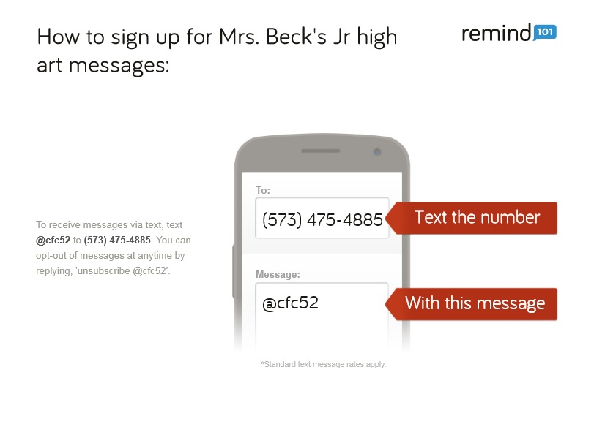
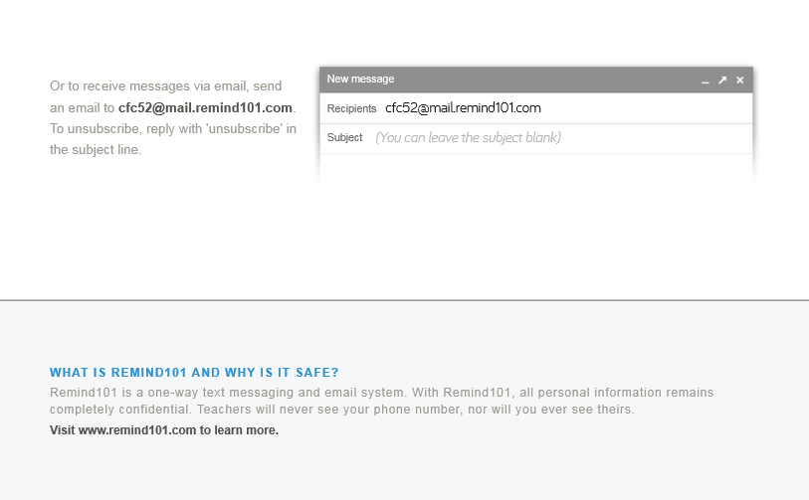
Course Syllabus
Junior High Art
Advance High School 2013-2014

COURSE DESCRIPTION
This course serves as a basic introduction to art media, techniques, criticism, and history. Junior High art requires a high commitment to the safe and responsible use of materials, tools, and equipment, as well as a commitment to art research and imaginative thinking. Students will view, discuss, and create art. Interdisciplinary studies are included from other areas such as Science, English, Math, History, and Technology.

GOALS OF VISUAL ARTS EDUCATION
Art in this classroom is built from knowledge of art and activities. Learning in art has four major areas.
The goal of art education is the development of these areas:
- by making art (art production);
- by responding to and making judgments about the properties and qualities that exist in visual forms (art criticism);
- by acquiring knowledge about the contributions artists and art makes to culture and society (art history);
- by understanding the nature, meaning, and value of art (aesthetics).

CLASS GUIDELINES FOR SUCCESS

1. Be prepared and on time for class – bring sketchbook, pencils, etc. to class every day.
2. Listen to and follow directions – ask questions.
3. Respect the people, equipment and furnishings in the art room. Get permission to use other’s materials.
4. Use your time wisely – stay on task and work towards project objectives.
5. Keep it clean- table, supplies, and LANGUAGE!
6. Have a positive attitude – you CAN do it!

If you CHOOSE not to follow the guidelines:
Step 1 – verbal warning
Step 2 – student/teacher conference about choice or behavior that is disruptive, inappropriate, or unacceptable and documentation
Step 3 – principle intervention, parent notification, and documentation
Step 4 – serious offense resulting in possible in-school or out-of-school suspension

Possible Art Projects
Possible art projects for the year are: drawing, printing, computer presentation, acrylic and watercolor painting, cardboard and paper sculptures, and clay.

1st AND 2nd SEMESTER FINALS
At the end of the first and second semester there will be a computer presentation and written final. Topics and a rubric will be given once the time draws closer to mid-term.

WEEKLY SKETCHBOOK TOPIC
Each week you will be given a sketchbook topic to draw and reflect on. The sketchbooks are due at the end of class each Friday. Sketchbook assignments are worth 10 points and go towards your total grade in the class.

Evaluation
Students will be graded on art projects, sketchbooks, presentations, quizzes, and daily participation.

Grading Scale:
100-90 = A
89-80 = B
79-70 = C
69-60 = D
Below 60 = F

EXTRA CREDIT
10 points of extra credit may be earned by attending any art related function outside of normal school/art class activities; such as gallery walks, artist openings/receptions, etc. Proof of attendance will be required.

ATTENDENCE AND DAILY POINTS
It is the responsibility for the student to check with the teacher when they have been absent in order to make up work. Each week you will earn 5 points for showing up to class and working in the class period. If you do not come to class, you cannot earn these points. If you have an excused absence, please show it to me so that you may earn the points that you have missed.

ARTSONIA AND WEEBLY
Currently, student artwork will be displayed in one of two areas, artsonia.com and mrsbeckdoesart.weebly.com. Artsonia is a free website that displays artwork from students from all over the nation and gives each student an individual name (ex. Cameron4555) to use and have their artwork under. I will be sending home permission slips for your parents to sign so I can display your artwork under Advance High, Mo, on this site. Your parent/guardian/other relatives can buy products with your artwork on it, and a small portion goes back to the school art account to buy more supplies for our class.

The Weebly site is a site I created to show your artwork, and also to allow you to find out what we have been doing in class if you have been absent. Links to videos we have watched, websites, and artists that you should be familiar with will be posted on the site under “Junior High Art”. I will also display some of the top work that I find in class on each project.

STUDENT / PARENT or GUARDIAN SIGNATURES
The junior high school art syllabus and curriculum must be signed and dated by a parent or guardian and the student, and turned in to Mrs. Beck by 8/23/13 for 5 points. This process will ensure that the student and parent/guardian have a clear understanding of the expectations and rules of this course.

Thank you,
Mrs. Samantha Beck
e-mail: sbeck@advance.k12.mo.us
webpage: mrsbeckdoesart.weebly.com

___________________________________ ______________________________________
Student signature Parent or Guardian signature
___________________________________ ______________________________________
Date Date

Parent/Guardian initial here if I can have permission to use photos of your child's artwork on the Weebly website.

Art Room Rules
Be an ARTIST
Act Responsible
Respect yourself, others, and materials
Try your Best
Imaginative and Creative
Safety
Talk Quietly

